Good luck to:____________________ Date__________

**Hindi 3CA Mid-term**

**Section 1) Write the days of the week**

Sunday:

Monday:

Tuesday:

Wednesday:

Thursday:

Friday:

Saturday:

**Section 2) Write the following vegetables/fruits in Hinglish.**

Apple:________Onion:____________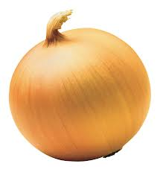

Cucumber:_______________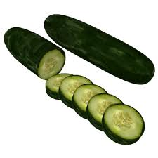 Tomato_________

**Section 3) Numbers: Translate the following numbers.**

Ek__________ Dus_________ Chouda___________

Sola________ Bees________ Tera______________

Pandrah_____ Cha_________ Paches___________

**Section 4) Translate the following greetings.**

1. Hello, what is your name? __________________________________
2. Do you speak English?_______________________________________
3. Where are you from?________________________________________
4. Did you like it?______________________________________________

**Section 5) Pick the correct answer regarding directions.**

1. I am looking for the bathroom. Where is it?
   1. Bathroom kidhar hai?
   2. Mai kaha hoon?
   3. Aap ka naam kya hai?
2. Aap kitna saal kai ho?
   1. Vo aaj aya nahi
   2. Mai ______saal ka hoon.
   3. Mai _____ kaksha main hoon
3. Translate: Mujhe maaf karna
   1. I’m a good boy
   2. Forgive me
   3. It is over there

**Section 6) Translate the feelings into Hindi**

I am happy__________________________

I am nervous__________________________

I am calm_______________________________

I am embarrassed_______________________

I am in love____________________________

I am angry_______________________________

I am scared__________________________

I am busy____________________________

**Section 7) Open ended section. Talk about your feelings today . Why are you feeling like this?**

**Section 8) Translate the animals into Hindi.**

Elephant_____________________ Peacock________________

Lion_______________ Bear____________

Bird___________________ Sheep_________________

**Section 9) Write about two different animals than the previously mentioned ones you saw at the zoo.**

**Section 10) Translate the weather in English**

Winter - Summer- Fall- Spring-

1) It’s cold outside___________________ 2_)It’s snowing______________

1. Turn up the heater___________________ 3) It’s very hot outside______________________

5) It’s a nice day_________________________ 6) It’s stormy________________________

7)It’s sunny__________________________ 8) It’s foggy__________________________

**Section 11) Translate the colors into Hindi.**

1. Red- 5)Pink-
2. Blue- 6)Brown-
3. Yellow- 7)Black